Test 1: Baseline Measurements of Communications parameters.
Configuration:
2-Node XBee Network
Laptop running X-CTU Range test program.
Remote Node has loopback installed.
Measurements:
-Rough quantative analysis of Range
-Qualative analysis of Data Throughput
-Qualative analysis of Node Reliability
Method:
-Take readings of RSSI manually and log rough distances from Coordinator.
Supplies:
-XBee Network setup installed in backpack
-Laptop
-GPS
-Tape Measure
-Notebook/Pencil
-Charged Walkie-Talkies
-2 XBee Battery packs
-Power Inverter
Procedure:
- Setup XBee Network to receive RSSI signals to Laptop running X-CTU Program, 9600 baud.
- Enlist Volunteer
- Measure Volunteer’s average stride.
- For each Location, walk 2 paths perpendicular to each other, for every x number stride record RSSI using Walkie-Talkies.
Locations:
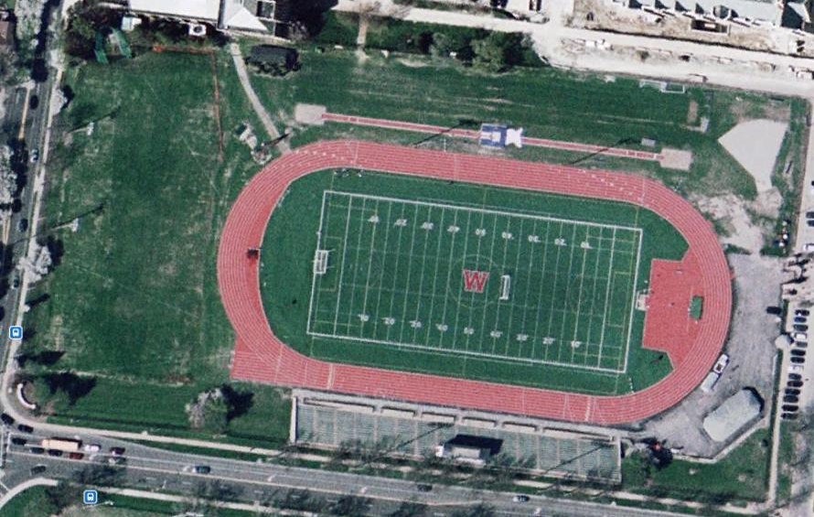
Location 1: Large, Flat, limited obstructions; Washington University Francis Field
NS Path: ~472 ft
EW Path: ~820 ft

Location 2: Large, Flat, minor obstructions; Golf Course near Washington University, GPS Coordinates:
38°38'41.60"N; 90°17'51.36"W
NS Path: ~641 ft
EW Path: ~1,120 ft
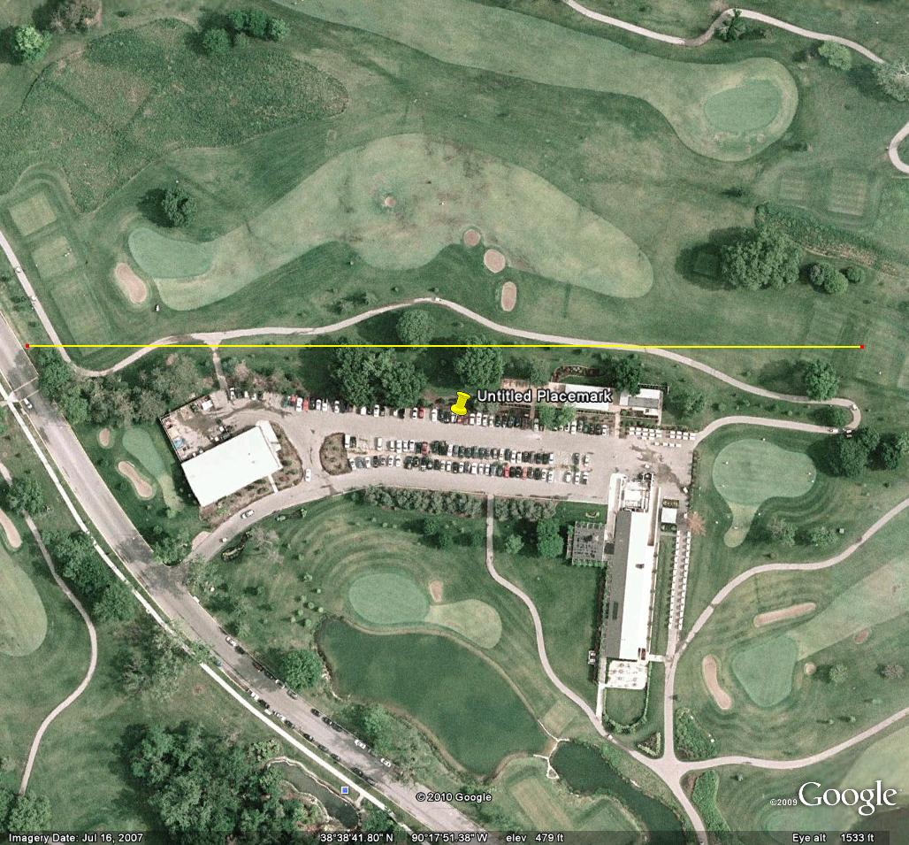

Location 1
Stride Number | Distance | RSSI NS Path | RSSI EW Path

Location 2
Stride Number | Distance | RSSI NS Path | RSSI EW Path

